Angle Rays
# Source: AI Source: Provided by: [Data Path: Persons Table -> ID Column: 1, Name_En Column: Motasem Essam] -> From: [ChatGPT] on [7/25/2026]
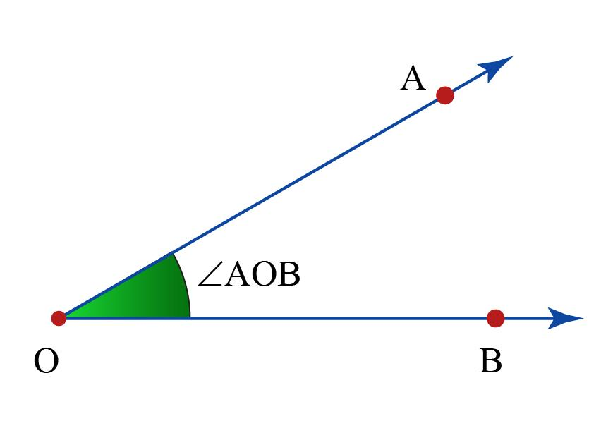
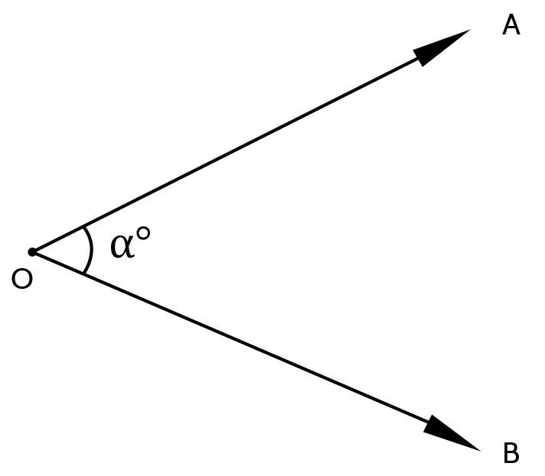
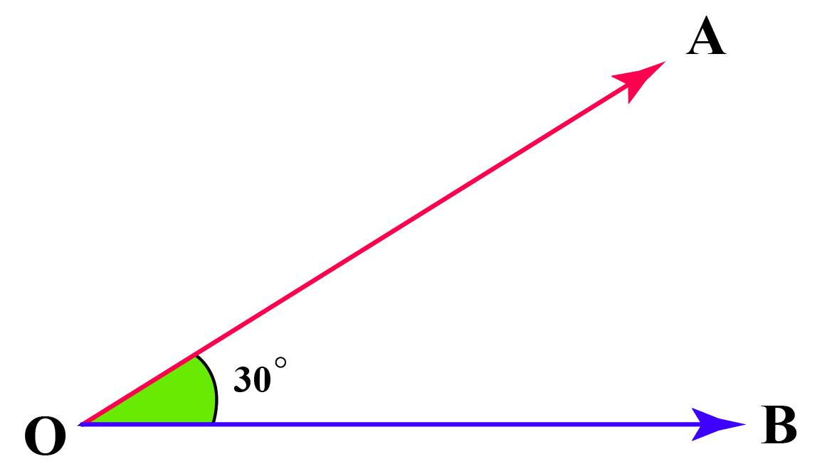
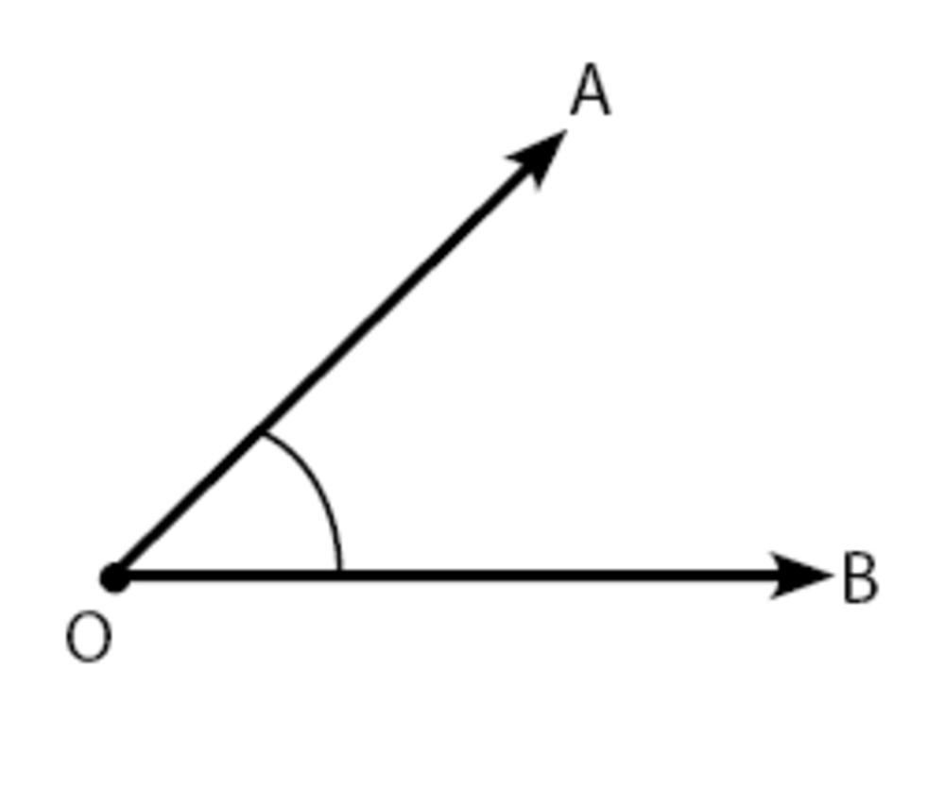
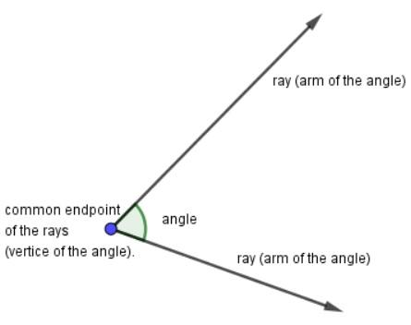

Definition
# Source: AI Source: Provided by: [Data Path: Persons Table -> ID Column: 1, Name_En Column: Motasem Essam] -> From: [ChatGPT] on [7/25/2026]
Angle Rays are two rays that share a common endpoint (called the vertex) and extend in different directions, forming an angle between them.
Every angle is formed by exactly two rays that begin at the same point.

Characteristics
# Source: AI Source: Provided by: [Data Path: Persons Table -> ID Column: 1, Name_En Column: Motasem Essam] -> From: [ChatGPT] on [7/25/2026]
Angle rays:
- Share one common endpoint.
- Extend infinitely from the common endpoint.
- Form an angle between them.
- The common endpoint is called the vertex.
- The rays are called the arms or sides of the angle.
- The angle can be acute, right, obtuse, straight, reflex, or complete.

Illustration
# Source: AI Source: Provided by: [Data Path: Persons Table -> ID Column: 1, Name_En Column: Motasem Essam] -> From: [ChatGPT] on [7/25/2026]
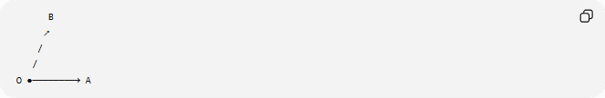
B
↗
/
/
O ●────────→ A
- Ray $\vec{OA}$
- Ray $\vec{OB}$
Together they form:
$$∠AOB$$

Mathematical Representation
# Source: AI Source: Provided by: [Data Path: Persons Table -> ID Column: 1, Name_En Column: Motasem Essam] -> From: [ChatGPT] on [7/25/2026]
If two rays
$$\vec{OA}$$
and
$$\vec{OB}$$
share endpoint
$$O$$
then they form
$$∠AOB$$
where:
- $O$= vertex
- $\vec{OA}$= first ray
- $\vec{OB}$= second ray

Coordinate Geometry
# Source: AI Source: Provided by: [Data Path: Persons Table -> ID Column: 1, Name_En Column: Motasem Essam] -> From: [ChatGPT] on [7/25/2026]
Suppose
$$O\left(0 , 0\right)$$
First ray passes through
$$A\left(5 , 0\right)$$
Second ray passes through
$$B\left(4 , 3\right)$$
The two rays form an angle at
$$O$$

Types of Angles Formed by Angle Rays
# Source: AI Source: Provided by: [Data Path: Persons Table -> ID Column: 1, Name_En Column: Motasem Essam] -> From: [ChatGPT] on [7/25/2026]
Depending on the opening between the rays:
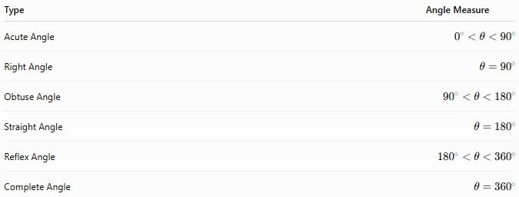
Type | Angle Measure
Acute Angle | $$0^{∘}<θ<{90}^{∘}$$
Right Angle | $$θ={90}^{∘}$$
Obtuse Angle | $${90}^{∘}<θ<{180}^{∘}$$
Straight Angle | $$θ={180}^{∘}$$
Reflex Angle | $${180}^{∘}<θ<{360}^{∘}$$
Complete Angle | $$θ={360}^{∘}$$

Examples
# Source: AI Source: Provided by: [Data Path: Persons Table -> ID Column: 1, Name_En Column: Motasem Essam] -> From: [ChatGPT] on [7/25/2026]
Examples of angle rays include:
- Clock hands.
- Open scissors.
- An open book.
- A door opened from its hinge.
- Two roads meeting at an intersection.

Properties
# Source: AI Source: Provided by: [Data Path: Persons Table -> ID Column: 1, Name_En Column: Motasem Essam] -> From: [ChatGPT] on [7/25/2026]
Angle rays:
- Share exactly one endpoint.
- Extend infinitely.
- Form exactly one angle.
- May form any angle measure from $0^{∘}$to ${360}^{∘}$.
- Determine the orientation of the angle.

Applications
# Source: AI Source: Provided by: [Data Path: Persons Table -> ID Column: 1, Name_En Column: Motasem Essam] -> From: [ChatGPT] on [7/25/2026]
Angle rays are used in:
- Plane Geometry
- Coordinate Geometry
- Trigonometry
- Engineering
- Architecture
- Construction
- Surveying
- CAD (Computer-Aided Design)
- Robotics
- Computer Graphics

Advantages
# Source: AI Source: Provided by: [Data Path: Persons Table -> ID Column: 1, Name_En Column: Motasem Essam] -> From: [ChatGPT] on [7/25/2026]
Studying angle rays helps to:
- Understand angle formation.
- Measure and classify angles.
- Construct geometric figures.
- Analyze direction and rotation.
- Solve trigonometric problems.

Limitations
# Source: AI Source: Provided by: [Data Path: Persons Table -> ID Column: 1, Name_En Column: Motasem Essam] -> From: [ChatGPT] on [7/25/2026]
Angle rays:
- Must share one common endpoint.
- Require two rays to define an angle.
- Do not have finite length.

Comparison with Related Objects
# Source: AI Source: Provided by: [Data Path: Persons Table -> ID Column: 1, Name_En Column: Motasem Essam] -> From: [ChatGPT] on [7/25/2026]
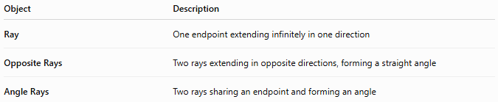
Object | Description
Ray | One endpoint extending infinitely in one direction
Opposite Rays | Two rays extending in opposite directions, forming a straight angle
Angle Rays | Two rays sharing an endpoint and forming an angle

Key Points
# Source: AI Source: Provided by: [Data Path: Persons Table -> ID Column: 1, Name_En Column: Motasem Essam] -> From: [ChatGPT] on [7/25/2026]
- Angle Rays are two rays sharing one endpoint.
- The shared endpoint is the vertex.
- The rays form:
$$∠AOB$$
- The angle may be acute, right, obtuse, straight, reflex, or complete.
- Angle rays are fundamental in geometry, trigonometry, engineering, architecture, surveying, CAD, robotics, and computer graphics.

Conclusion
# Source: AI Source: Provided by: [Data Path: Persons Table -> ID Column: 1, Name_En Column: Motasem Essam] -> From: [ChatGPT] on [7/25/2026]
Angle Rays are two rays that originate from a common endpoint and extend infinitely in different directions, creating an angle between them. The common endpoint is called the vertex, while the rays form the sides of the angle. By varying the direction of the rays, any type of angle—from acute to complete—can be formed. Angle rays are fundamental in plane geometry, coordinate geometry, trigonometry, engineering, architecture, construction, surveying, CAD, robotics, and computer graphics, where they provide the basis for measuring, constructing, and analyzing angular relationships and directional changes.

